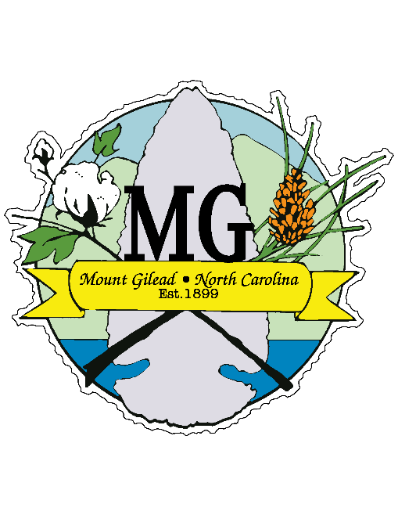**TOWN OF MOUNT GILEAD**

**BOARD OF COMMISSIONERS**

**MEETING NOTICE**

**110 West Allenton Street, Mount Gilead, North Carolina, 27306**

**PUBLIC NOTICE**

**NOTICE** is hereby given that the monthly Mount Gilead Town Board Meeting is rescheduled for November 12, 2024 at 7:00pm. The meeting will be held at the Mount Gilead Volunteer Fire Department, 100 E. Allenton St., Mount Gilead, NC 27306. Please direct any questions or concerns to Town Manager Dylan Haman at dhaman@mtgileadnc.com or (910)-439-6687.

Posted: October 17, 2024

LDJ