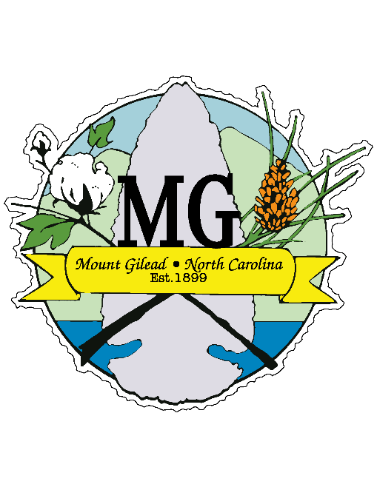**TOWN OF MOUNT GILEAD**

**PLANNING BOARD**

**MINUTES**

**110 West Allenton Street, Mount Gilead, North Carolina, 27306**

**May 12, 2022**

The Mount Gilead Planning Board met Thursday, May 12, 2022 at 5:30 pm at Mount Gilead Town Hall, 110 West Allenton Street, Mount Gilead, North Carolina.

CALL TO ORDER

Mr. David Smith opened the meeting at 5:29 pm. Members present were Mr. Devon Little, Mr. Jim Sharpe, Mrs. Joyce Robinson, Mr. Mitchell Lucas, Mrs. Edwina Martin, Mrs. Jessica Ingram and Mr. Lynn Smith connected via cell phone.

ITEM I. ADOPTION OF AGENDA

ITEM II. APPROVAL OF MINUTES

1. Meeting Minutes – October 28, 2021

ITEM III. PUBLIC COMMENT - None

ITEM IV. OLD BUSINESS - None

ITEM V. NEW BUSINESS

1. Proposed Zoning Ordinance Changes - Mr. Smith welcomed the members and explained the purpose of the proposed zoning changes is to align the Zoning Ordinance and the 2040 Comprehensive Plan. These areas are described as Main Street/Julius Chambers Overlay District. On Main street, from the area of First Baptist Church up to the Parkertown area. On Wadesboro Blvd and Julius Chambers Avenue, from the Dollar General area to the railroad track area.
2. Public Hearing-Proposed Zoning Ordinance Changes – Tracy Turner, Realtor/Developer spoke to the group about interest in a property on West Allenton Street in hopes of having a special events venue. Kathy Moody also requested a change in the zoning map to reclassify her home place from the Industrial District to Residential 15 District.
3. Board Discussion and Action – After discussion, the motions were made to make the changes to Article 4.5 Table of Permitted Uses and all were successfully approved.

ITEM VI. ADJOURNMENT – Meeting was adjourned at 8:20 pm.